D-311 Unit 5 WildCAD-E (ANSWER KEY)

WildCAD-E Overview Exercises (30 Mins) Handout 3

Instructor led exercises utilizing the WildCAD-E Dispatch Application.

Incident creation

Exercise 3.1
SMOKE REPORT
Caller Tilda Canterberry 658-333-2354 is on CA Hwy 33 at Pine Mountain Summit and sees a smoke column about 1 mile to the east. (Answer Place name PINE MTN RD/HWY 33). Follow previous naming convention for Incident.
Incident should look like this <Student Action>
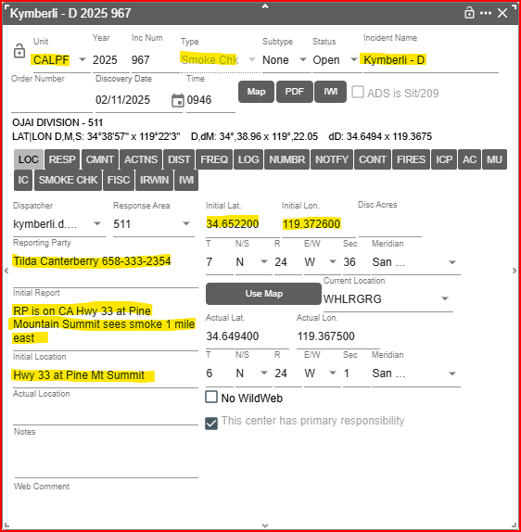

You call Duty Officer Smith to notify him of the report and he wants you to dispatch LPF E355 and E352 and see what they find.
Approximately 30 mins later E355 calls on the radio and let you know they have arrived on scene and states that they have a 1-acre fire on FS Jurisdiction, with low rate of spread. They will get back to you with a full size up in 5 minutes.
Log tab should be documented similar to this <Student Action>
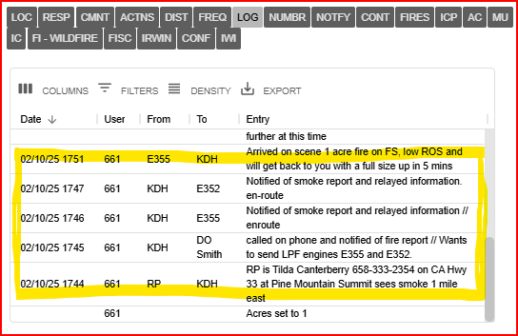
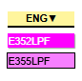
Response Tab should show E355 On scene and E352 Responding.

SIZE UP
E355 calls on the radio on Repeater Sisar Peak with a full size-up “Fire Name Reyes Peak, Lat/Long is 34.6494 x 119.3675 on Reyes Peak Road about 3 miles in from Hwy 33 at Pine Mountain Summit. 1 Acre, burning in grass and brush, Character of fire is creeping/smoldering, Low rate of spread, 5400’ elevation, on a flat aspect and right next to the road. 0-10% slope, winds are 5mph from the west, there are no control issues, no property threatened, and hazards are public traveling the FS Road. Only additional resource needed E352 that is already en-route but has not arrived on scene, and a fire investigator. ICT5 will be Becky Campbell and ICT5 trainee is David Stuart. Believe the fire to be human caused due to proximity to the roadway. Nothing further at this time.”
5 mins later E352 calls on the radio to notify they have arrived on-scene and are tying in with the IC.
Duty Officer Smith Calls to get an update on the fire.
<Student Action> Dispatcher should document all (Size up, E352 On-scene, the call from DO Smith & update was given) in the Incident log, Fires tab, IC tab, Freq tab – Sisar Pk and Response tab as the calls are coming in.
LOC Tab
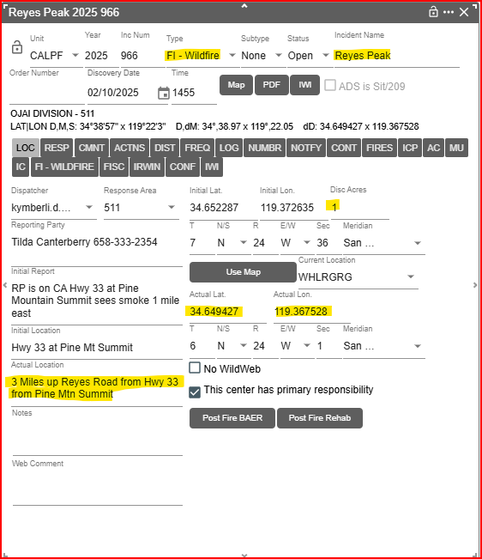
<Student Action> FREQ Tab
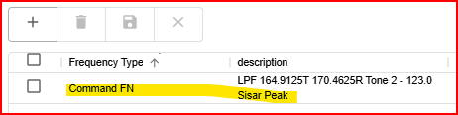
<Student Action> IC Tab
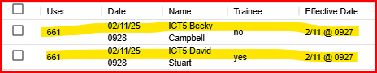

<Student Action> FIRES Tab
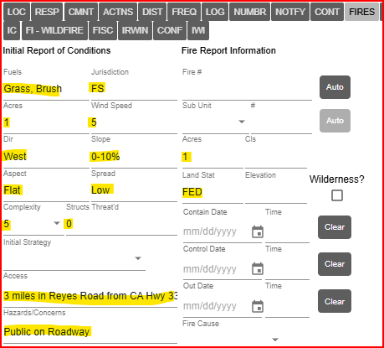

<Student Action> LOG Tab (Incident)
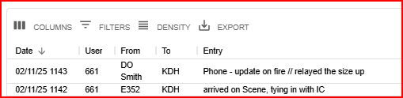
<Student Action> RESP Tab
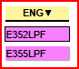 Both Resources Show On scene
FOLLOW UP
2 Hours later the IC calls in to notify you that the fire was contained and will be in patrol status and all resources are departing the fire for station.
<Student Action> LOG Tab (Incident)
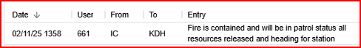
<Student Action> RESP Tab
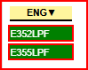 Resources should show Returning
<Student Action> FIRES Tab
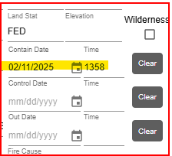
Should have entered a contain date.

Pdf incident – Student can .pdf incident and email to coach they can review and go back over any errors later.
Exercise results
You should have created a new incident mapped and Header, LOC Tab, RESP Tab, LOG Tab, FREQ Tab, IC Tab, and FIRES Tab filled out with information.

